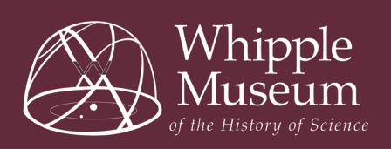
Whipple Museum of the History of Science
Work Experience
Expression of Interest Form

Thank you for your interest in work experience with the University of Cambridge Museums. Please complete this form and return to: hps-whipple-museum@lists.cam.ac.uk or Learning Coordinator, Whipple Museum of the History of Science, Free School Lane, Cambridge, CB2 3RH.

This opportunity is open to those aged 14-18 years old. Please note that if you are offered work experience, you are required to clear this with your school. Further information at: https://www.museums.cam.ac.uk/Opportunities

Your contact details
Title
First name(s)
Surname
Date of birth
Home Address | Postcode:
Email address
Home telephone number
Mobile telephone number
School you attend

About you
Please provide a brief outline of any particular skills, areas of study, interests or experiences that you would like to develop through this work experience opportunity, and explain why you would like to be selected to participate. Max 200 words.

How did you hear about this opportunity?
We offer one week of work experience in the museum, or two weeks of work experience between the museum and library. Please indicate your preference:

One week at the museum □   One week in the Library □   Two weeks in both □

Dates are available in these ranges only:
17th – 28th June 8th – 19th July 16th – 27th September
Please indicate what your preferred dates would be:

Special Requirements
If you require any special arrangements to be made to attend an initial induction meeting or if you have any medical conditions you’d like us to take into consideration, please specify those here. This information is requested so that we may care for your needs and will be kept confidential.
Emergency Contact Details
Please give details of your next of kin to contact in case of emergency.
Name
Relationship to you
Address | Postcode:
Email address
Daytime tel number

Your personal information provided on this form will be kept in accordance with GDPR. Your information will be held securely and confidentially and accessed only by authorised persons, which shall include our funders Arts Council England. Anonymised aspects of the information given by you may be used for statistical purposes. I declare the information I have provided is true:

Signed Date

I give consent that my son/daughter can attend this Work Experience opportunity within our locality

Parent/guardian’s signature:

Print name: Date:

How the Whipple Museum of the History of Science and the Whipple Library uses your personal information: The Whipple Museum of the History of Science and the Whipple Library uses your personal information to contact you about volunteer roles or projects that you have applied for and other related activities.

We use your personal information in order to deliver our contractual obligations to you as a user of our service. More information about our work can be found on our website: https://www.museums.cam.ac.uk/
For more information about how we handle your personal information, and your rights under data protection legislation, please see https://www.information-compliance.admin.cam.ac.uk/data-protection/general-data

